
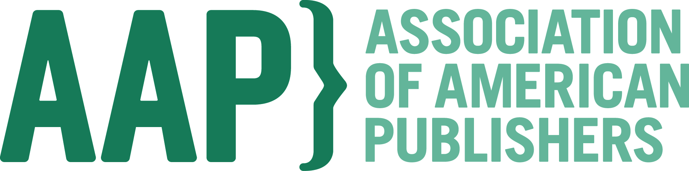

Library Reads & the Association of American Publishers
Welcome you to BookExpo America 2015!
Wednesday, May 27 - Friday, May 29, 2015, New York City.
(As of April 1, 2015; Speakers and Topics Subject to Change)

Wednesday, May 27
6:30 pm. Ninth Annual BookExpo America Adult Librarians’ Dinner, Yale Club, NYC (50 Vanderbilt Avenue, Grand Ballroom) Featuring: Al Roker, Storm of the Century (William Morrow) & Master of Ceremonies; Karin Slaughter, Pretty Girls, (William Morrow); Ernest Cline, Armada (Crown/Penguin Random House); Sloane Crosley, The Clasp (FSG/Macmillan); Lauren Groff, Fates & Furies (Riverhead/Penguin Random House); and James Patterson, Cross Justice, (Little, Brown & Co). Please register your interest to attend HERE, and we will confirm if we are able to meet your request.

7:00 pm. Fourth Annual BookExpo America Children’s Librarians’ Dinner, Co-Hosted by AAP and School Library Journal, Cornell Club, NYC (6 E. 44th Street) Featuring: Jeff Anderson, Zack Delacruz: Me and My Big Mouth, Sterling Children’s Books; Mike Curato, Little Elliot, Big City, Henry Holt/Macmillan Children’s Publishing Group ; Matt de la Pena, Last Stop on Market Street, Putnam Juvenile/Penguin Young Readers Group; Candace Fleming & Eric Rohmann, Bulldozer’s Big Day, Atheneum/Simon & Schuster; Kevin Henkes, Waiting, Greenwillow/HarperCollins Children’s Books; and Adam Silvera, More Happy Than Not, Soho Teen. Please register your interest to attend HERE, and we will confirm if we are able to meet your request.

Thursday, May 28
12 pm – 1:30 pm. Annual BEA Adult Librarians’ Author Lunch. Jacob K. Javits Center (Room 1E15-16) Featuring: Tama Janowitz, Scream (Dey Street, HarperCollins); Barry Moser, We Were Brothers (Algonquin/Workman); Stephanie Clifford, Everybody Rise (St. Martins Press/Macmillan); Vu Tran, Dragonfish, A Novel (W. W. Norton); Annie Barrows, The Truth According to Us, (The Dial Press/Penguin Random House); and Mary Louise Parker, Dear Mr. You (Scribner/Simon & Schuster) Please register your interest to attend HERE, and we will confirm if we are able to meet your request.

1:45-3:15 pm. AAP Annual Librarians’ Book Buzz—Part I. Jacob K. Javits Center (Room 1E14)
Hear the first installment of what book publishers are excited about for the forthcoming season, and learn their behind the scenes secrets why! Dominique R. Jenkins Academic Conventions and Library Marketing Manager, Penguin Group USA; Jen Childs, Director, Library Marketing, Random House; Michelle Fadlalla, Director of Marketing, Education & Library, Simon & Schuster; Michael Rockliff, Director of Library Sales and Marketing, Workman, Golda Rademacher, Library Marketing Manager, W. W. Norton; Linda Hollick, Publisher, New York Review Books; and Meredith Barnes, Soho Press.

Friday, May 29
2:00 pm – 3:30 pm. AAP Annual Librarians’ Book Buzz—Part II. Jacob K. Javits Center (Room 1E14)
Hear the second installment of what book publishers are excited about for the forthcoming season, and why. The second installment will feature publishers; Virginia Stanley, Director of Library Marketing, HarperCollins; Elenita, Chmilowski, Library Marketing Director, Perseus Books Group; Melissa Nicholas, Library Marketing Manager, Hachette Book Group, Chris Vaccari, Director, Library Marketing, Sterling; Talia Sherer, Director, Library Marketing, Macmillan; Claire Kelley, Marketing Manager, Melville House; and Julie Schaper, President, Consortium Book Distribution, and Jean Johnson, National Accounts Manager for Schools and Libraries Sourcebooks.
3:30 pm – 5 pm. Seventh Annual Librarian Shout ‘n Share @ Book Expo. Jacob K. Javits Center (Room 1E14), Co-sponsored by the AAP and Library Journal. Librarians gather at the close of the 2nd day of BEA to talk about their most recent discoveries on the exhibit floor, and upcoming works they are looking forward to sharing with their patrons. Wilda Williams, Fiction Editor, Library Journal moderates this year’s Shout N Sharers: Kristi Chadwick, Advisor, Small Libraries Massachusetts Library System; Charlene Rue, Acting Director of BookOps, New York & Brooklyn Public Libraries; Jamie Watson, Collection Development Coordinator, Baltimore County Public Library; Jennifer Dayton, Collection Development Manager, Darien Library; and Robin Nesbitt, Collection Development, Columbus Public Library.

# # #

